1. 
2. d
   1. So this algo runs in quadratic time.
   2. Algo that runs in O (n^2) gets slower than the algo that runs in O (n).  
      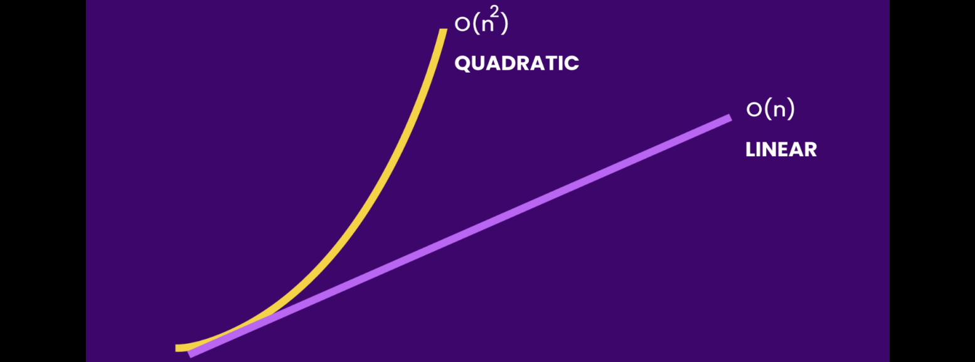
   3. The difference depends on the size of input.   
      If an array of size let’s say 25 then we will not see any difference.
3. 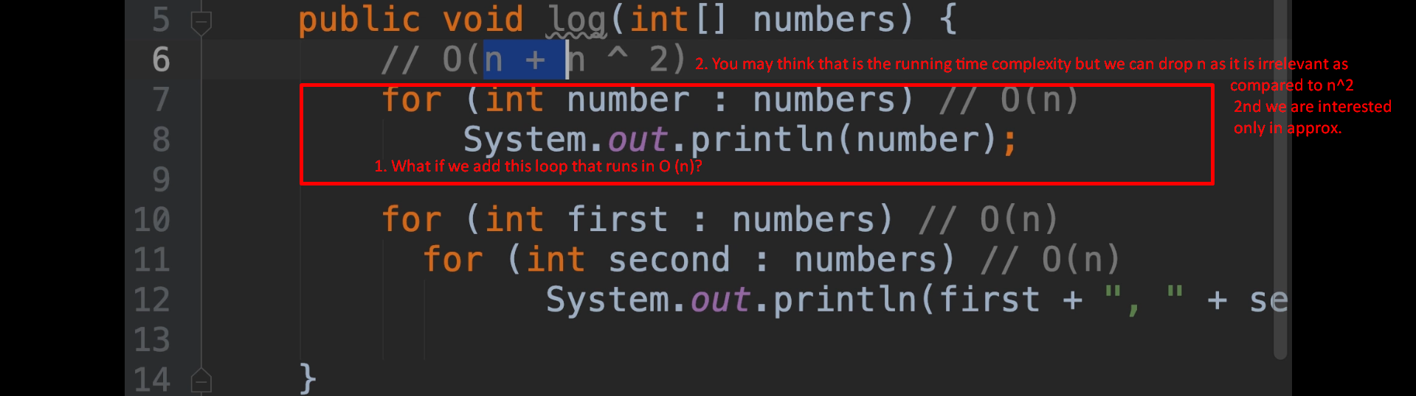
4. 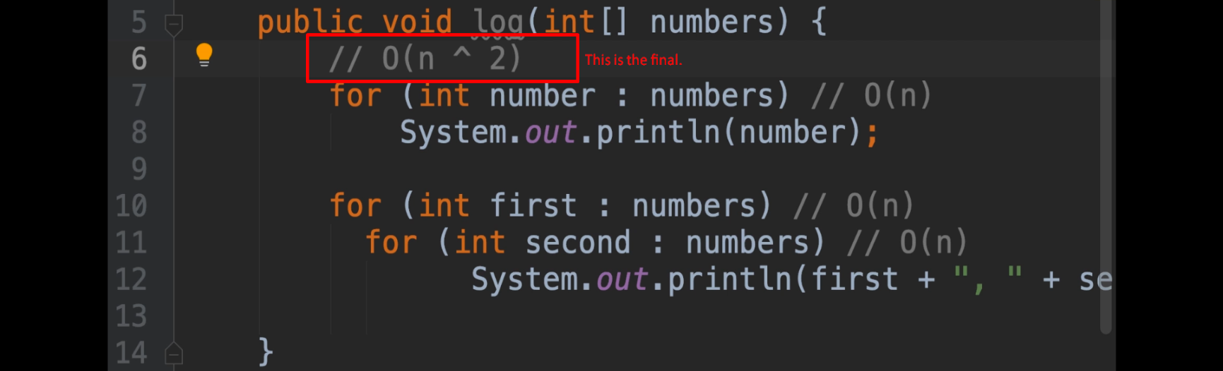
5. 